DEXTA
Screening Log
Site training aid

1. Purpose
This document provides site staff with clear instructions on how to use the paper screening log and how and when to upload screening information to REDCap. Accurate and timely completion of the screening log ensures complete reporting of all babies assessed for the trial and supports correct completion of the REDCap monthly screening report.

2. Instructions for paper screening log
Who Should Be Recorded
- Record all babies born at less than 32 weeks’ gestation.
- Each baby should have one individual entry on the paper screening log.

What to Record
For each eligible baby:
- Gestational age at birth
- Eligibility status for DEXTA
- Consent status
- If consent is not obtained, record the main reason for non-consent
- If the baby is not eligible, record the reason for ineligibility

Ongoing Monitoring
- Babies’ eligibility and consent status may change during their NICU stay.
- Continue to monitor and update the paper screening log throughout the baby’s admission.
- Ensure any changes (e.g. eligibility changes, consent obtained later, discharge, or death) are clearly documented on the paper log.

3. Instructions for uploading screening data to REDcap
When to Enter Data into REDCap
- Only upload screening data to REDCap once an outcome for the baby has been reached.
- Outcomes include:
  - Fixed ineligibility
  - Consent not obtained for a fixed reason
  - Baby discharged
  - Baby died
Do not upload to REDCap while the baby is still being actively screened.
How to Enter Data
- In REDCap, enter screening data using the “Screening Log” form.
- Upload only one final reason per participant.
- Ensure:
  - The correct outcome reason is selected
  - The form status is marked “Complete”
  - Click Save and Exit or Go to Next Form

4. Screening flow diagram instructions
- Gestational Age Check
  - Determine whether the baby was born at < 32 weeks’ gestation.
  - If ≥ 32 weeks:
    - No further screening is required
    - No entry in REDCap
- Paper Screening Log Entry
  - If < 32 weeks, enter the baby’s details onto the paper screening log.
  - Assess eligibility for DEXTA.
- Consent and Eligibility Assessment
  - If eligible and consent obtained:
    - Record consent details on the paper screening log
    - No REDCap upload required
  - If not eligible or consent not obtained, determine the reason type.
- Fixed vs Provisional Reasons
  - Fixed outcomes (A–E):
    - Record the reason in the fixed outcome column
    - Add the baby to the monthly screening report in REDCap
  - Provisional reasons (F–L):
    - Record the reason as provisional
    - Continue screening and monitoring
- Final Outcome
  - If a provisional reason later becomes fixed, or if the baby is discharged or dies:
    - Update the paper screening log with the final outcome
    - Add the baby to the REDCap monthly screening report for the appropriate month

5. Screening flow diagram
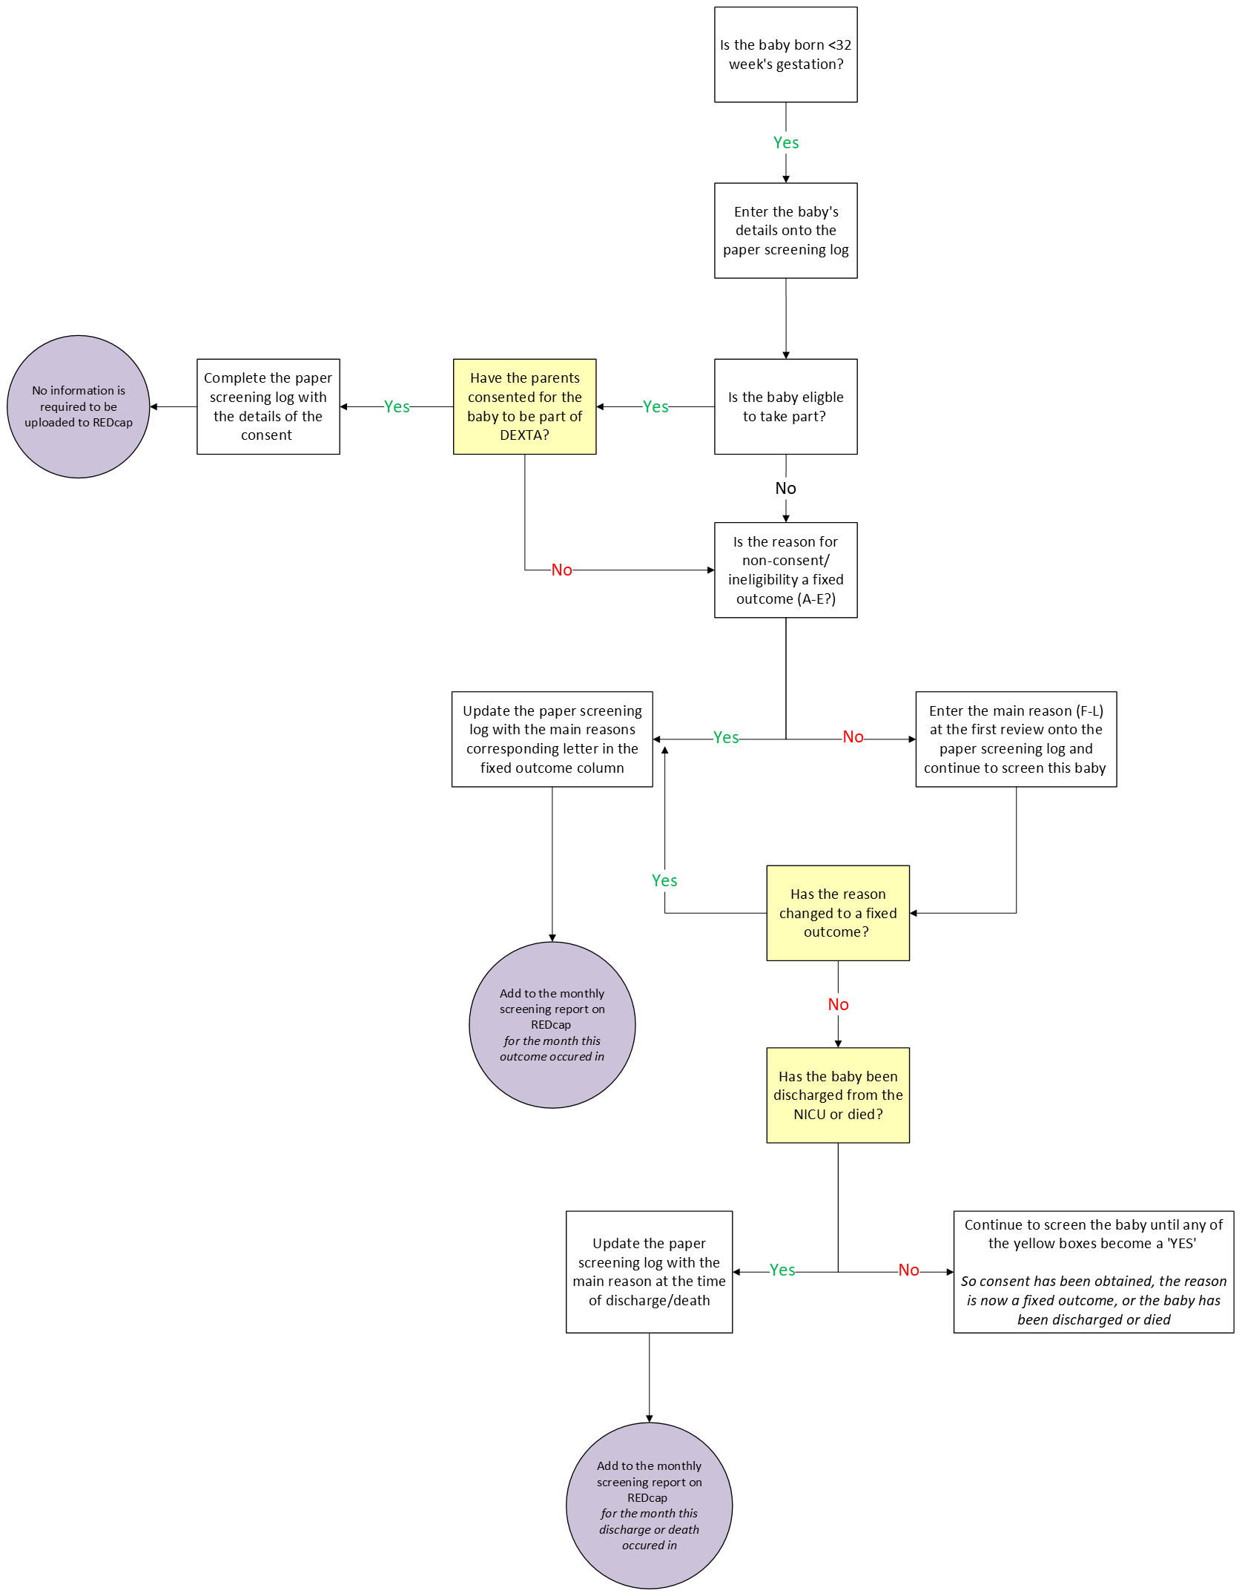

6. Summary
- ✔ Record all babies < 32 weeks on the paper screening log
- ✔ Keep the paper log up to date throughout the NICU stay
- ✔ Record only one final outcome reason per baby in REDCap
- ✔ Do not upload to REDCap until a final outcome is reached
- ✔ Ensure REDCap forms are marked “Complete” before saving
- ✔ Babies with consent obtained do not require REDCap screening upload

